`ME- **Manat** on Camel

Terracotta figurine of **Manat** on Camel, 16 cm. x 13 cm.

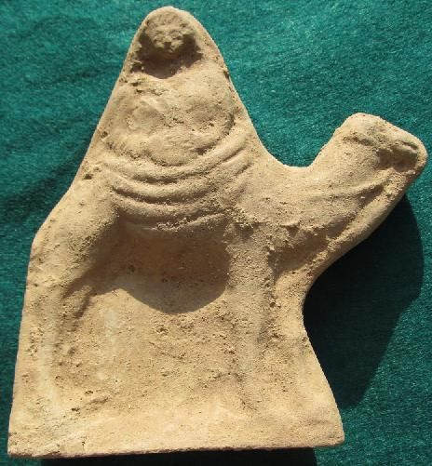

**Fig. 1. Half-body statuette** wearing a tunic covered by a himation gown and secured on camelback by a heavily folded tapestry. She is portrayed as holding, with both hands, a round object, One interpretation is that it is a tambourine, a musical instrument that was played by women accompanying ceremonial processions in military triumphs in pre-Islamic Arabia. Another interpretation is that it was a sacred globular stone, a baetyl, in which a deity inhered with magical apotropaic powers. In either case the seated figure is performing a ritual rite to protect her believers. It should also be noted that "A rider on a camel is an iconographical convention representing Arabia or the Nabatean kingdom" ( Patrich 1990:73, n. 53).

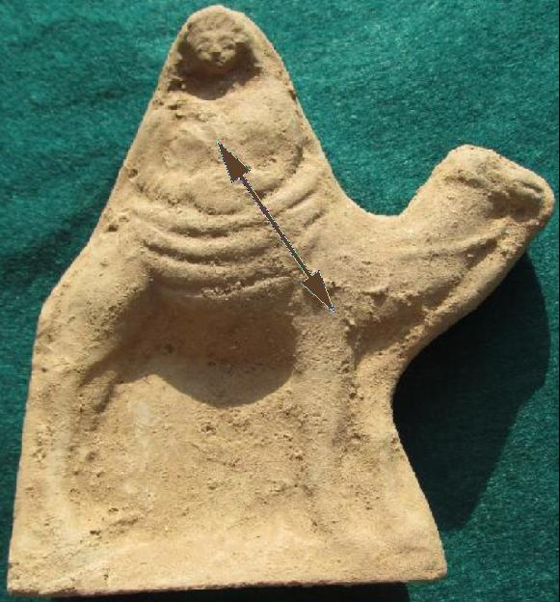

Fig. 2. **Fig. 1. Half-body statuette of Manat.** A diagonal feature that was applied when the clay was wet but has since been broken off. This may have been the double pointed arrow of Menat.

A case for this statuette being a figure of Manat is that there is a hint of a diagonal feature that had been applied when the clay was wet but has since been broken off. This may have been the double pointed arrow of Menat.

**Manāt** ([Arabic](http://en.wikipedia.org/wiki/Arabic_language): مناة‎; also transliterated as *manāh*) was one of the three chief goddesses of [Mecca](http://en.wikipedia.org/wiki/Mecca).[[1]](http://en.wikipedia.org/wiki/Manāt" \l "cite_note-book-1) The pre-Islamic Arabs believed Manāt to be the goddess of fate. She was known by the cognate name *Manawat* to the [Nabataeans](http://en.wikipedia.org/wiki/Nabataeans) of [Petra](http://en.wikipedia.org/wiki/Petra), who equated her with the Graeco-Roman goddess [Nemesis](http://en.wikipedia.org/wiki/Nemesis_(mythology)) and she was considered the wife of [Hubal](http://en.wikipedia.org/wiki/Hubal).[[2]](http://en.wikipedia.org/wiki/Manāt" \l "cite_note-2) The [Qur'an](http://en.wikipedia.org/wiki/Qur'an) confirmed that the pre-Islamic Arabs believed that some female idols were daughters of God, like [Allāt](http://en.wikipedia.org/wiki/Al-lāt), [Al-‘Uzzá](http://en.wikipedia.org/wiki/Al-‘Uzzá), and Manāt.[[3]](http://en.wikipedia.org/wiki/Manāt" \l "cite_note-3) According to Grunebaum in *Classical Islam*, the Arabic name of Manat is the linguistic counterpart of the Hellenistic [Tyche](http://en.wikipedia.org/wiki/Tyche), [Dahr](http://en.wikipedia.org/w/index.php?title=Dahr&action=edit&redlink=1), fateful 'Time' who snatches men away and robs their existence of purpose and value. There are also connections with [Chronos](http://en.wikipedia.org/wiki/Chronos) of [Mithraism](http://en.wikipedia.org/wiki/Mithraism) and [Zurvan](http://en.wikipedia.org/wiki/Zurvan) mythology.[[4]](http://en.wikipedia.org/wiki/Manāt" \l "cite_note-4) The [*Book of Idols*](http://en.wikipedia.org/wiki/Book_of_Idols) describes her:

The most ancient of all these idols was Manāt. The Arabs used to name [their children] 'Abd-Manāt and Zayd-Manāt. Manāt was erected on the seashore in the vicinity of al-Mushallal in Qudayd, between [Medina](http://en.wikipedia.org/wiki/Medina) and [Mecca](http://en.wikipedia.org/wiki/Mecca). All the Arabs used to venerate her and sacrifice before her. The Aws and the Khazraj, as well as the inhabitants of Medina and Mecca and their vicinities, used to venerate Manāt, sacrifice before her, and bring unto her their offerings... The Aws and the Khazraj, as well as those Arabs among the people of [Yathrib](http://en.wikipedia.org/wiki/Yathrib) and other places who took to their way of life, were wont to go on pilgrimage and observe the vigil at all the appointed places, but not shave their heads. At the end of the pilgrimage, however, when they were about to return home, they would set out to the place where Manāt stood, shave their heads, and stay there a while. They did not consider their pilgrimage completed until they visited Manāt.

—*Book of Idols*, pp 12–14[[5]](http://en.wikipedia.org/wiki/Manāt" \l "cite_note-5)

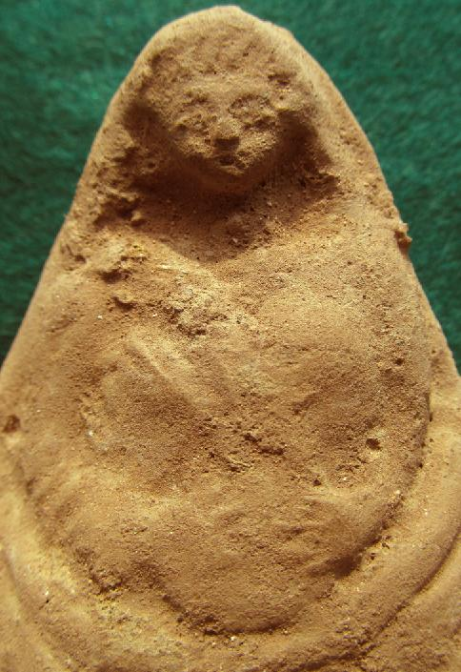

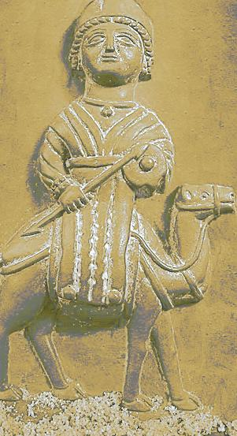 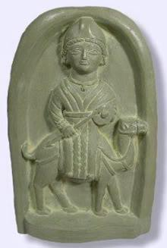

Manat (Manah) on a camel, with tambourine and double arrowhead baton as an apotropaic device in a bas-relief from the city of Taif, Saudi Arabia, around 100 AD.

Left: Relief after http://upload.wikimedia.org/wikipedia/commons/d/d6/Allat.jpg.

Right: Plaque relief after http://i946.photobucket.com/albums/ad308/Thelitesoul/al-lat.jpg

Manat (Manah) had the two pointed sword Dhu al-Faqar that in Islamic mythology is the two-pointed magical sword that represents ‘Ali, fourth caliph and son-in-law of Muhammad. It was originally owned by an unbeliever, al-‘As ibn Munabbih, Dhu al-faqar. Ali found this sword when he was ordered by Muhammed to destroy the idol, Manah. He found this sword together with another one as a part of the treasure given to Manah by the Arabs as religious offerings. (The Encyclopedia of Islam, Vol. 2)

**Manah** (from the book of Idols)

"The most ancient of all Arab idols was Manah. The Arabs used to name [their children] 'Abd-Manah and Zayd-Manah. Manah was erected on the seashore in the vicinity of al-Mushallal in Qudayd, between Medina and Mecca. All the Arabs used to venerate her and sacrifice before her. [In particular] the Aws[[6]](http://answering-islam.org/Books/Al-Kalbi/manah.htm" \l "6%236) and the Khazraj, as well as the inhabitants of Medina and Mecca and their vicinities, used to venerate Manah, sacrifice before her, and bring unto her their offerings. No body venerated her more than the Aws and the Khazraj.

During the Jahiliyah days, the Arabs were used to call both the Aws and the Khazraj by the single generic name, al-Khazraj. For this reason the part said, "at the sacred place of the Khazraj." This Manah is that which God mentioned when He said, "And Manah, the third idol besides." She was the [goddess] of the Hudhayl and the Khuza'ah.

The Quraysh as well as the rest of the Arabs continued to venerate Manah until the Apostle of God set out from Medina in the eighth year of the Hijrah, the year in which God accorded him the victory. When he was at a distance of four or five nights from Medina, he dispatched 'Ali to destroy her. 'Ali demolished her, took away all her [treasures], and carried them back to the Prophet. Among the treasures which 'Ali carried away were two swords which had been presented to [Manah] by al-Harith ibn-abi-Shamir al-Ghassani, the king of Ghassan. The one sword was called Mikhdham and the other Rasub. They are the two swords of al-Harith which 'Alqamah mentions in one of his poems. He said:

"Wearing two coats of mail as well as   
Two studded swords, Mikhdham and Rasub

The Prophet gave these two swords to 'Ali. It is, therefore, said that dhu-al-Faqar, the sword of 'Ali, was one of them.

It is also said that 'Ali found these two swords in [the temple of] al-Fals[[21]](http://answering-islam.org/Books/Al-Kalbi/manah.htm" \l "21%2321), the idol of the Tayyi', whither the Prophet had sent him, and which he also destroyed[[1]](#footnote-2)"

[http://answering-islam.org/Books/Al-Kalbi/manah.htm#14](http://answering-islam.org/Books/Al-Kalbi/manah.htm" \l "14)

Franz Cumont has drawn attention to the double Fortuna divinity of the Semites and their processions on the backs of camels in his 1917 *Études syriennes* in which he reproduces a terracotta figurine from Damascus of these figures:

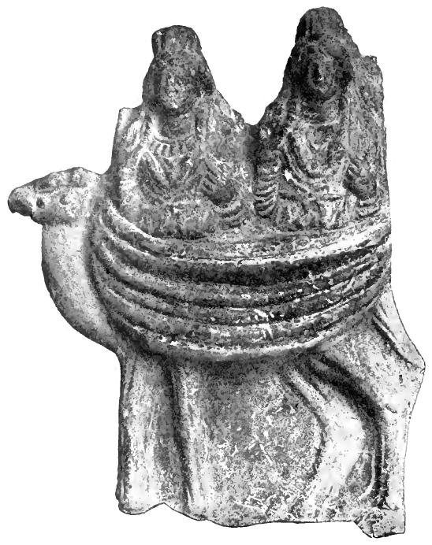

Terracotta figurine of two half-body statuettes of female divinities from the region around Damascus. Now in Musée du Louvre (acc. 6608). From Cumont 1917: 264, Fig. 93.

Cumont wrote of this terracotta : "In 1913 I found an Armenian merchant amidst a lot of antique shops in Damascus who had a singular terracotta which I bought [and which I later placed in the Louvre]. It offers a unique representation for those who have interest in Syrian Arab religion of two deities in twin litters on camel back." Cumont goes on to explain how the saddle holding the statuettes is "concealed under the broad folds of cloth stretched around the camel in which are placed two feminine statues, [both f which are] exactly the same, cut at the waist" Cumont 1917: 263.

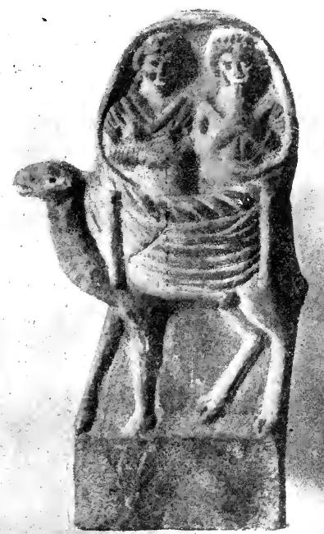

Terracotta from Syria. After Cumont 1917: 273, Fig. 94. (Musée du Louvre)

This is a similar figurine with the left figure holing a flute and the right figure holding a tambourine.

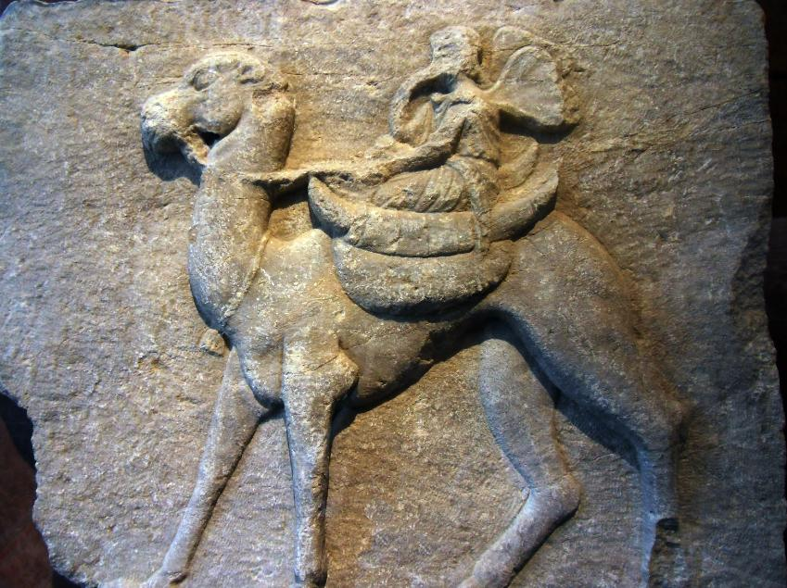

"Votive relief (?) Psyche on a camel Second century. BCE, Alexandria Troas (Turkey) Marble. (Musée du Louvre). After: cheminsantiques.blogspot.com.   
Cumont makes reference to this little bas-relief of Psyche perched on a dromedary (Cumont 1917:271). It could symbolize Psyche as a psychopomp leading the soul on its journey to the world of the Blessed.

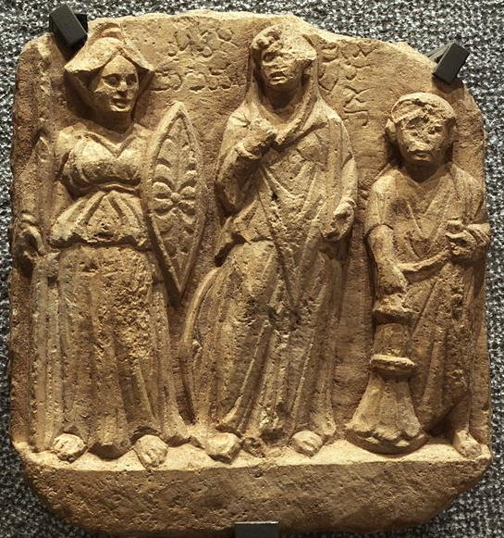

1. Bas-relief: [Nemesis](http://en.wikipedia.org/wiki/Nemesis_(mythology)) (Manat), [Allāt](http://en.wikipedia.org/wiki/Allāt) and the dedicator, 2nd or 3rd century CE, Limestone, from Palmyra, since 1990 in Musée des beaux-arts de Lyon.
2. The pre-Islamic Arabs believed Manāt to be the goddess of fate. She was known by the cognate name *Manawat* to the [Nabataeans](http://en.wikipedia.org/wiki/Nabataeans) of [Petra](http://en.wikipedia.org/wiki/Petra), who equated her with the Graeco-Roman goddess [Nemesis](http://en.wikipedia.org/wiki/Nemesis_(mythology)) and she was considered the wife of [Hubal](http://en.wikipedia.org/wiki/Hubal).[[2]](http://en.wikipedia.org/wiki/Manāt" \l "cite_note-2) The [Qur'an](http://en.wikipedia.org/wiki/Qur'an) confirmed that the pre-Islamic Arabs believed that some female idols were daughters of God, like [Allāt](http://en.wikipedia.org/wiki/Al-lāt), [Al-‘Uzzá](http://en.wikipedia.org/wiki/Al-‘Uzzá), and Manāt.[[3]](http://en.wikipedia.org/wiki/Manāt" \l "cite_note-3)
3. • ^ ***[a](http://en.wikipedia.org/wiki/Al-lāt" \l "cite_ref-Tabari_25_Sep_1990_46_1-0)*** ***[b](http://en.wikipedia.org/wiki/Al-lāt" \l "cite_ref-Tabari_25_Sep_1990_46_1-1)*** Tabari, Al (25 Sep 1990), [*The last years of the Prophet (translated by Isma'il Qurban Husayn)*](http://books.google.co.uk/books?id=XxG8BsHNw-MC&pg=PA46), State University of New York Press, p. 46, [ISBN](http://en.wikipedia.org/wiki/International_Standard_Book_Number) [978-0887066917](http://en.wikipedia.org/wiki/Special:BookSources/978-0887066917)
4. • ^ ***[a](http://en.wikipedia.org/wiki/Al-lāt" \l "cite_ref-Hawarey_2-0)*** ***[b](http://en.wikipedia.org/wiki/Al-lāt" \l "cite_ref-Hawarey_2-1)*** Hawarey, [Dr. Mosab](http://mosab.hawarey.org/) (2010). [*The Journey of Prophecy; Days of Peace and War (Arabic)*](http://www.islamic-book.net/ar/Rihlat-Alnobowwah.htm). Islamic Book Trust.Note: Book contains a list of battles of Muhammad in Arabic, English translation available [here](http://military.hawarey.org/military_english.htm), and archive of page [here](http://www.webcitation.org/5zLhjeYyz)
5. • ^ ***[a](http://en.wikipedia.org/wiki/Al-lāt" \l "cite_ref-Muir_August_1878_207_3-0)*** ***[b](http://en.wikipedia.org/wiki/Al-lāt" \l "cite_ref-Muir_August_1878_207_3-1)*** Muir, William (August 1878), [*The life of Mahomet (Full free digitized version)*](http://books.google.co.uk/books?id=YTwBAAAAQAAJ&pg=PA207), Kessinger Publishing Co, p. 207
6. • ^ ***[a](http://en.wikipedia.org/wiki/Al-lāt" \l "cite_ref-Muir_August_1878_205_4-0)*** ***[b](http://en.wikipedia.org/wiki/Al-lāt" \l "cite_ref-Muir_August_1878_205_4-1)*** Muir, William (August 1878), [*The life of Mahomet (Full free digitized version)*](http://books.google.co.uk/books?id=YTwBAAAAQAAJ&pg=PA205), Kessinger Publishing Co, p. 205

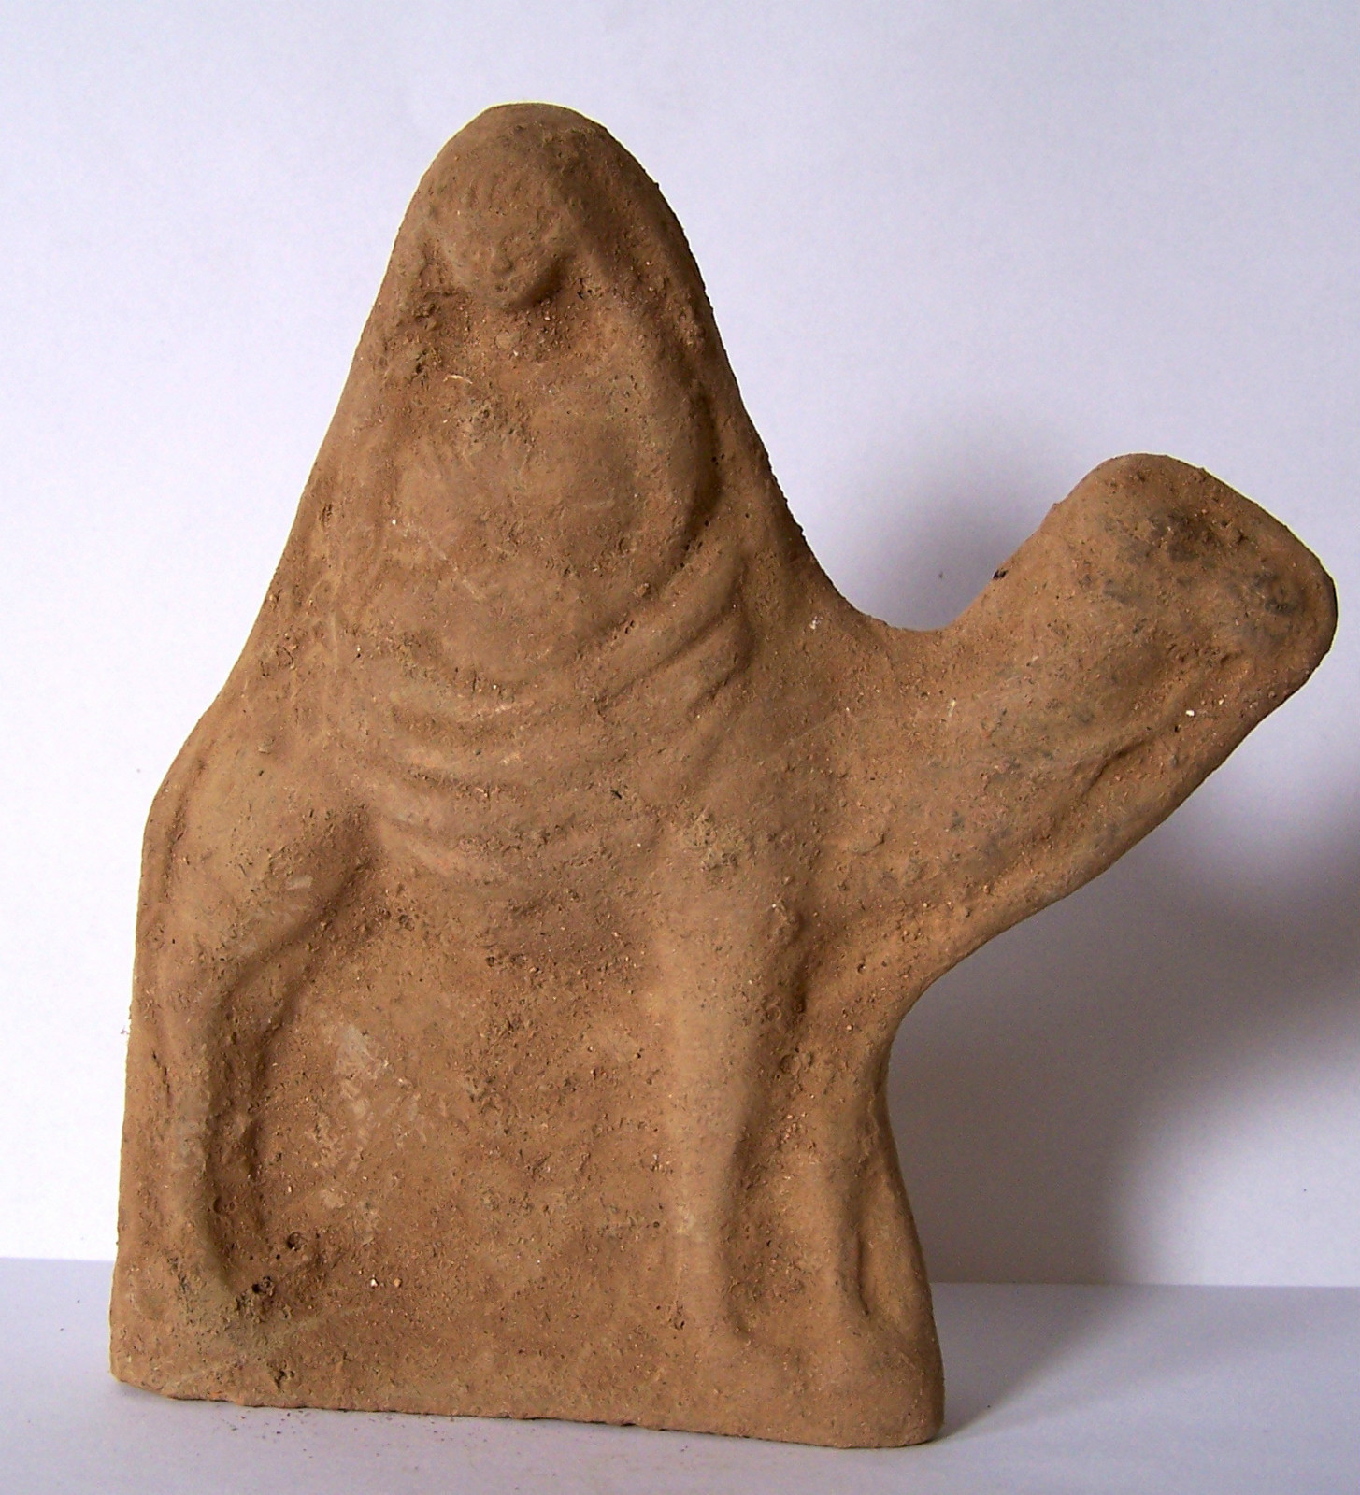 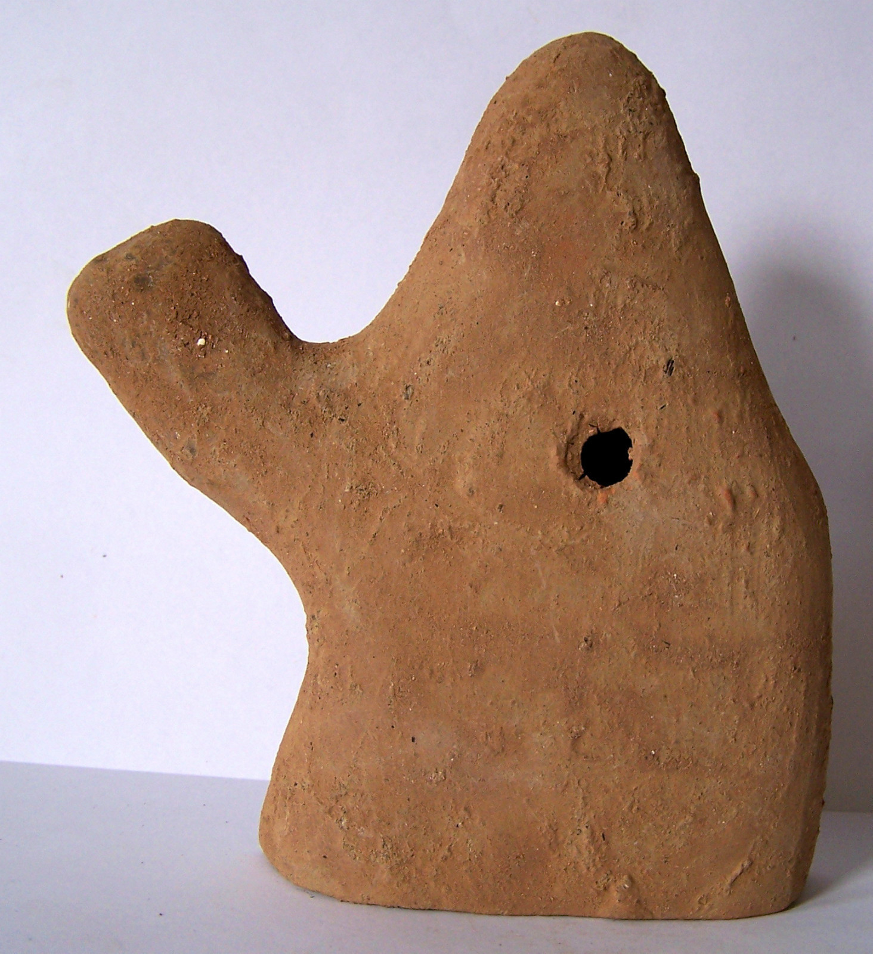

| Shipping details |
| --- |
| **Ralph J Coffman Jr**  149 Atlantic Ave  Swampscott MA 01907-2427  United States |

## Order details

|  |  |  |  |
| --- | --- | --- | --- |
| **Item title** | **Available actions** | **Shipping & handling (estimated delivery\*)** | **Price** |

[Printer version](http://payments.ebay.com/ws/eBayISAPI.dll?ViewPaymentStatus&transid=0&userloginid=802-867&orderid=125303748018&printerversion=true&itemid=271104286471)

|  |  |  |
| --- | --- | --- |
| Seller: | [**Member id** antiquewd](http://myworld.ebay.com/antiquewd) ( [**Feedback Score Of** 1459](http://feedback.ebay.com/ws/eBayISAPI.dll?ViewFeedback&userid=antiquewd)) | [Contact seller](http://contact.ebay.com/ws/eBayISAPI.dll?ShowCoreAskSellerQuestion&frm=3998&iid=0&redirect=0&requested=antiquewd) |

|  |
| --- |
| **Order # 125303748018**  Paid on Nov-18-12 via PayPal |

   Price**Paid or notItem shipped or notFeedback left or notFeedback received or not**Actions**antiquewd**

[**Member id** antiquewd](http://myworld.ebay.com/antiquewd/&_trksid=p3984.m1439.l2754) | [**Feedback Score Of** 1459](http://feedback.ebay.com/ws/eBayISAPI.dll?ViewFeedback2&userid=antiquewd&_trksid=p3984.m1439.l2776) | 98.5%

**Roman style clay statue figure**

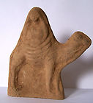

[Roman style clay statue figure](http://www.ebay.com/itm/271104345336?ssPageName=STRK:MEWNX:IT&_trksid=p3984.m1439.l2649) (271104345336)

Your max bid: $25.00

Sale date: 11/18/12

Tracking number: --

Estimated Delivery: 11/21/12 - 11/26/12

$9.99

**Paid with PayPal on November 18, 2012.**

**Not shipped**

**Feedback not left**

**Feedback not received**

|  |
| --- |
| [**Leave feedback**](http://feedback.ebay.com/ws/eBayISAPI.dll?LeaveFeedbackShow&useridto=antiquewd&item=271104345336&transactID=0&ssPageName=STRK:MEWNX:LF&_trksid=p3984.m1439.l2665) |
| [Sell this item](http://cgi5.ebay.com/ws/eBayISAPI.dll?SellLikeItem&item=271104345336&ssPageName=STRK:MEWNX:LILT&_trksid=p3984.m1439.l2667) |
| [More actions](javascript:;) |

1. This story also explains the first term in this list. [↑](#footnote-ref-2)